Public Notice of a Catoosa Public Library Board Meeting

Type of Meeting: Regular
Day: Tuesday January 23, 2024
Time: 5:00 p.m.
Place: Catoosa Public Library 105 E. Oak Street, Catoosa, Oklahoma

Agenda
I: Meeting convenes:
- Call the meeting to order
- Roll Call
C. This is a 15-minute period for comments from the General Public on Library related
non-agenda items. Preference will be given to Catoosa citizens. No formal action will be taken. Speakers are limited to three (3) minutes.

II: Agenda items:

The following items are designated for discussion, consideration, and possible action.

Item #1. Approval of the September 26, 2023 minutes
Discussion, consideration and possible action to approve the September 26, 2023 minutes.

Item #2. Approval of financial statements
Discussion, consideration, and possible action to approve the Library Recreational Fund (410) and financial report from July 27, 2023 to present.

Item #3. Librarian reports:
Discussion of librarian reports including collection and usage statistics.

III: Library Board Comments:

IV: Adjourn:
This agenda was posted on January 19, 2024 on the right side of the south front door of the Library at 105 E. Oak. Catoosa, Oklahoma and on the Library’s website at www.catoosapubliclibrary.com.
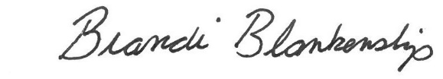
__________________________________________________
Brandi Blankenship, Library Director

