Ebooks & Audiobooks: Getting Started

This document will provide step-by-step instructions to help you navigate through setting up your device in order to be able to check out digital materials from the library. Don’t worry if it seems a little complicated. You will only have to do steps 1-10 the first time you go through the setup.

Step 1: Install the Overdrive App on your device.
- Go to the app store on your device:
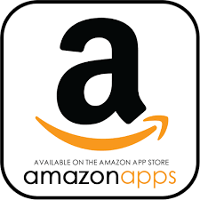
Google Play App Store Amazon Appstore Microsoft Store
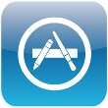
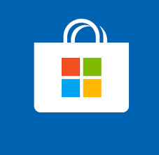

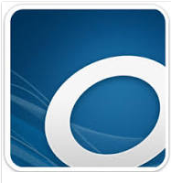
- Search in store for “Overdrive.”
- Click the icon that looks like this:
- Then click the “Get” or “Install” button

Step 2: Locate the Overdrive App and click to open it.

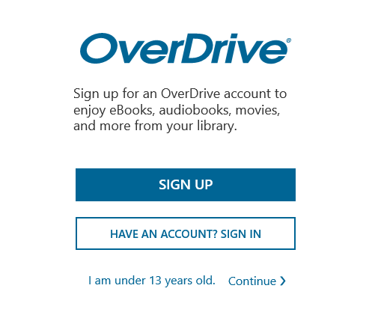
Step 3: Click “Sign Up”

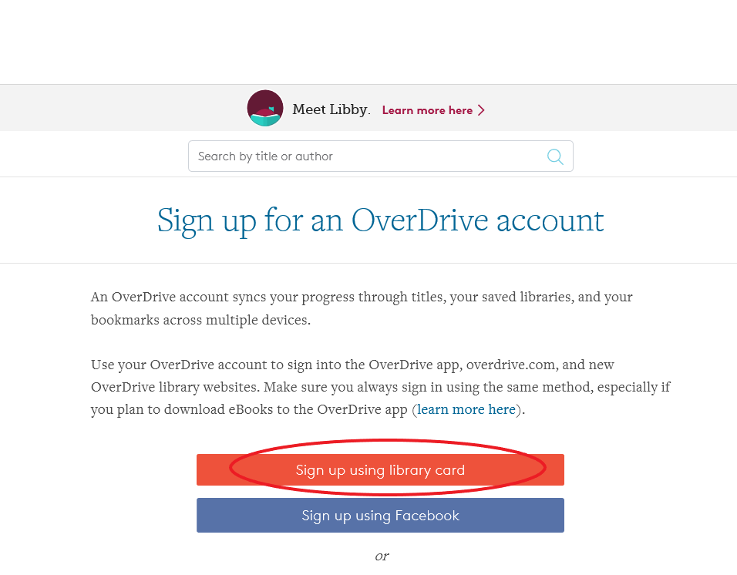
Step 4: Click “Sign Up Using
Library Card”

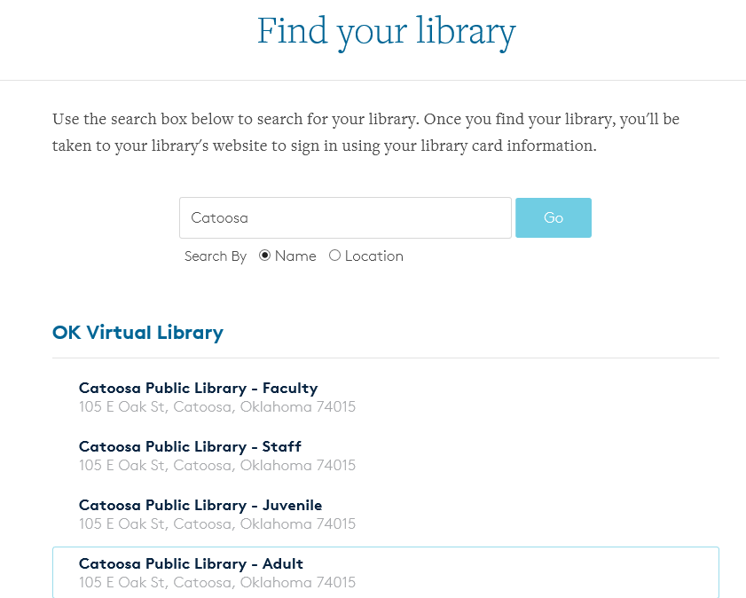
Step 5: Search for Catoosa Library
- Enter “Catoosa” in the search box
and press “go”
- Under “OK Virtual Library” select
“Catoosa Public Library – Adult”
for adult accounts or “Catoosa
Public Library – Juvenile”
for children under 18

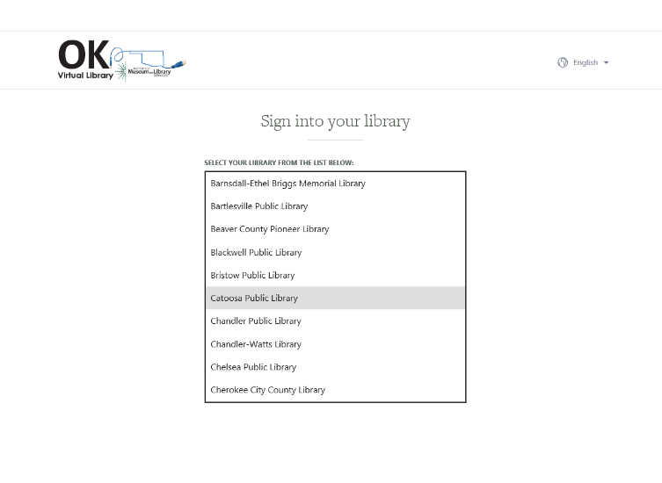
Step 6: Select Catoosa Public
Library from the list
- Use the drop down arrow
to see more choices

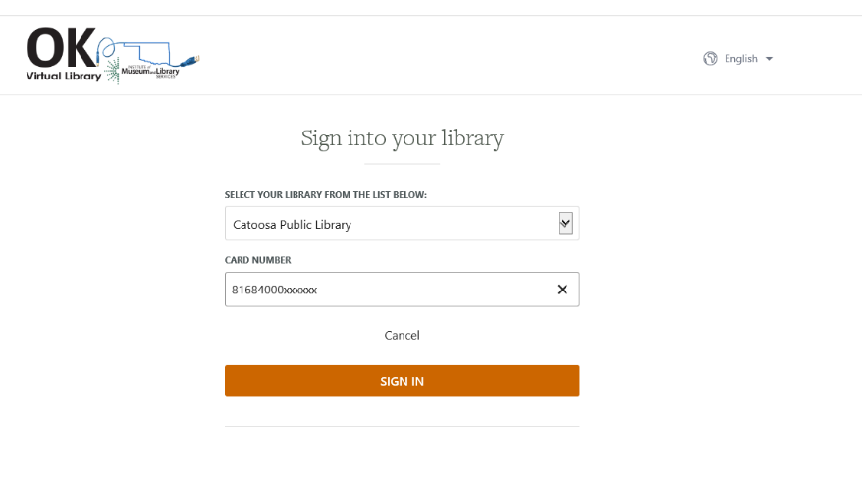
Step 7: Enter your full card
number and click “sign in.”

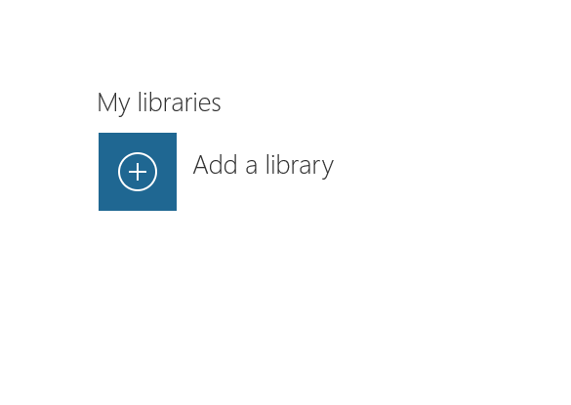
Step 8: Click “Add a Library”
(may look a little different,
depending upon which device
you are using)

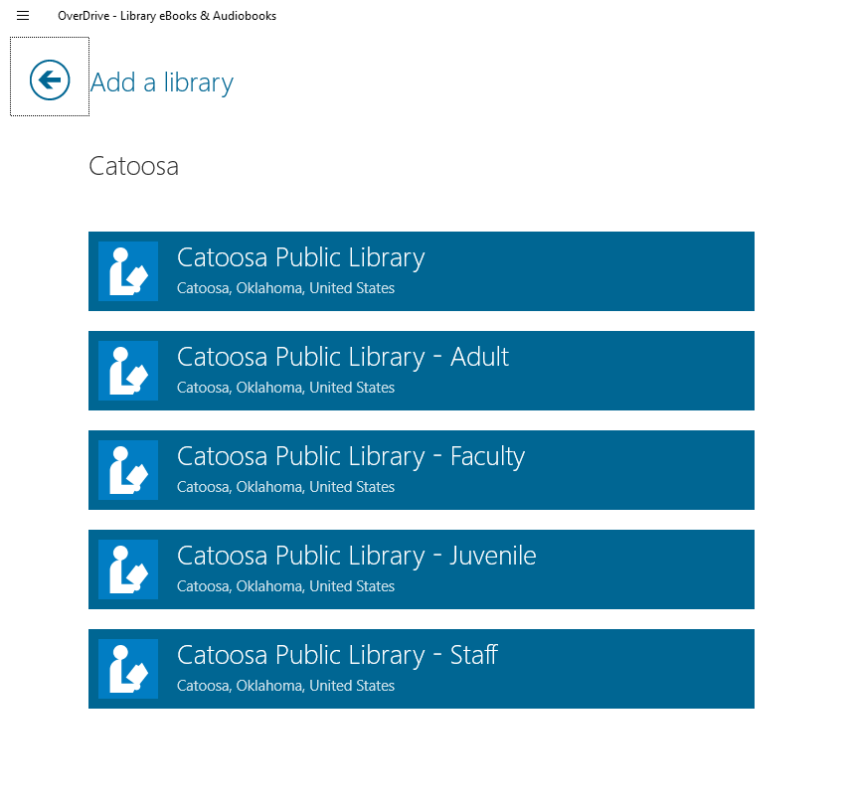
Step 9: Search for “Catoosa” again
- Select “Catoosa Public Library – Adult”
or “Catoosa Public Library – Juvenile”
again

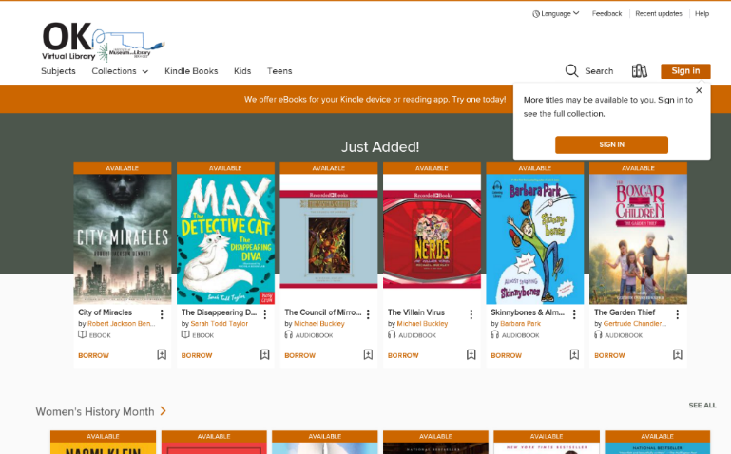
Step 10: Click “OK Virtual Library”
Step 11: Click “Sign In”

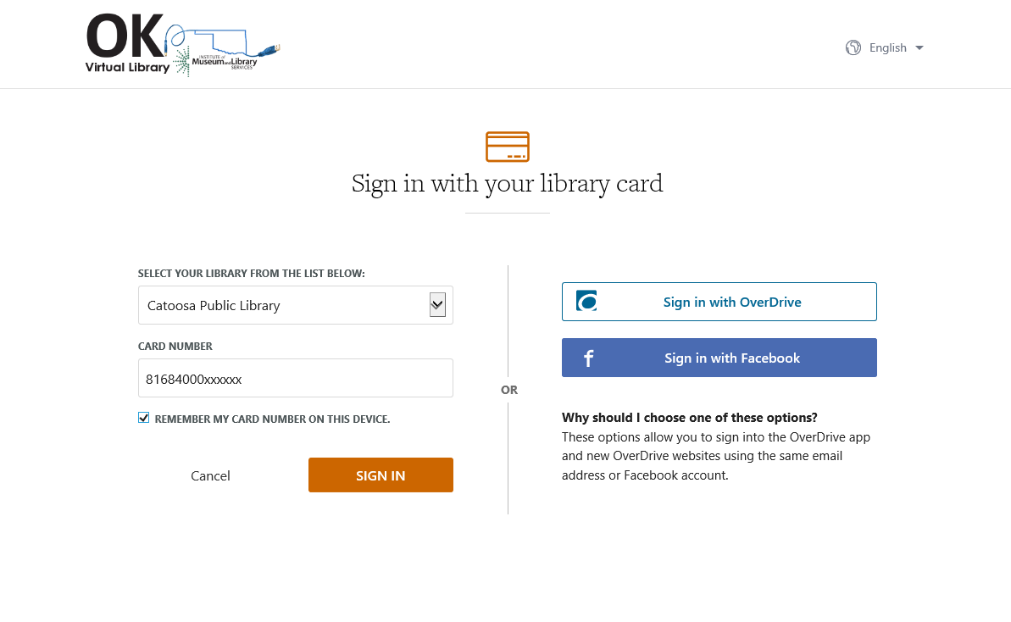
Step 12: Select “Catoosa
Public Library” from the list
again.
Step: 13: Enter your full card
number.
- You can check the box next to
“Remember my card number
On this device” so you will not
Have to enter it the next time.

You are now logged in and can search for ebooks and audiobooks, put items on hold, or create a wish list of items that you want to remember later.

